AnudipFoundation
Class = EXCEL(Basic) (LAB-1)
Date: 18-02-2026
Name: Soumyadip Das
Student ID: AF05102864
Topic: Basic Excel
- Rows, Column, Cell, Name Box,
- Sheet Add, Rename, Border, Select Sell, All type of select.
- Title Bar, Quick Access Toolbar, Ribbon Tab, Ribbon Etc.
- Cell Reference.
Customise Ribbon
File-Options-Customize Ribbon-New Tab-Rename Tab-New Group-Rename Group-Add Ribbon- Ok
- Hide Ribbon
- Remove Ribbon
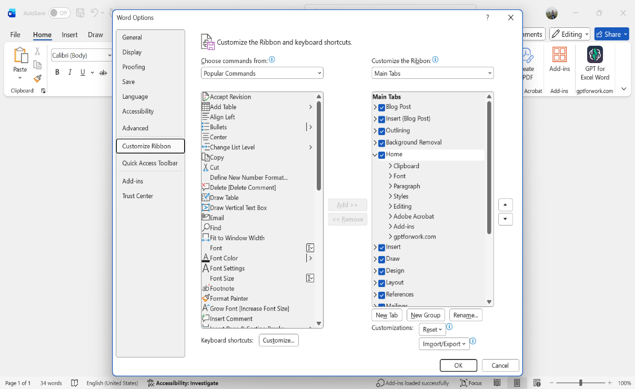

SUM using Formula:
- =SUM(ColumnRow:ColumnRow)

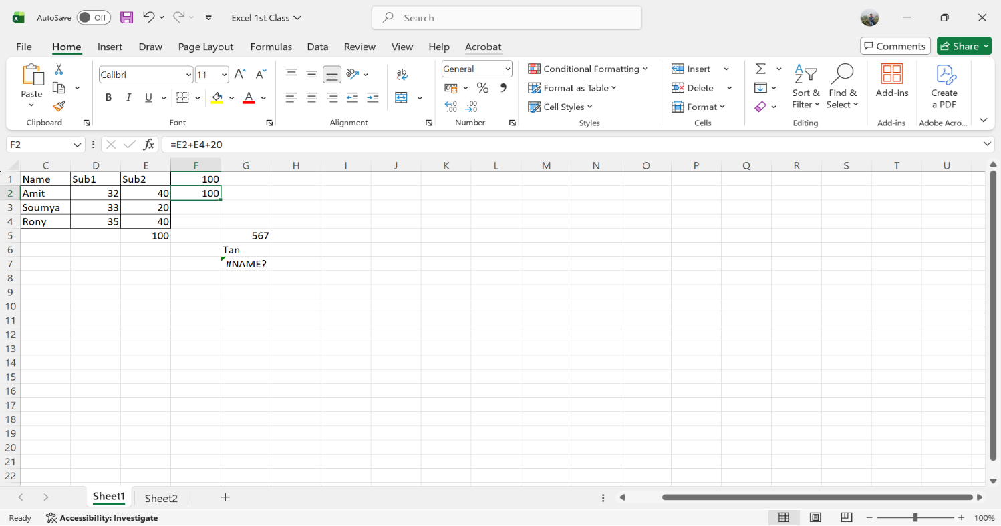
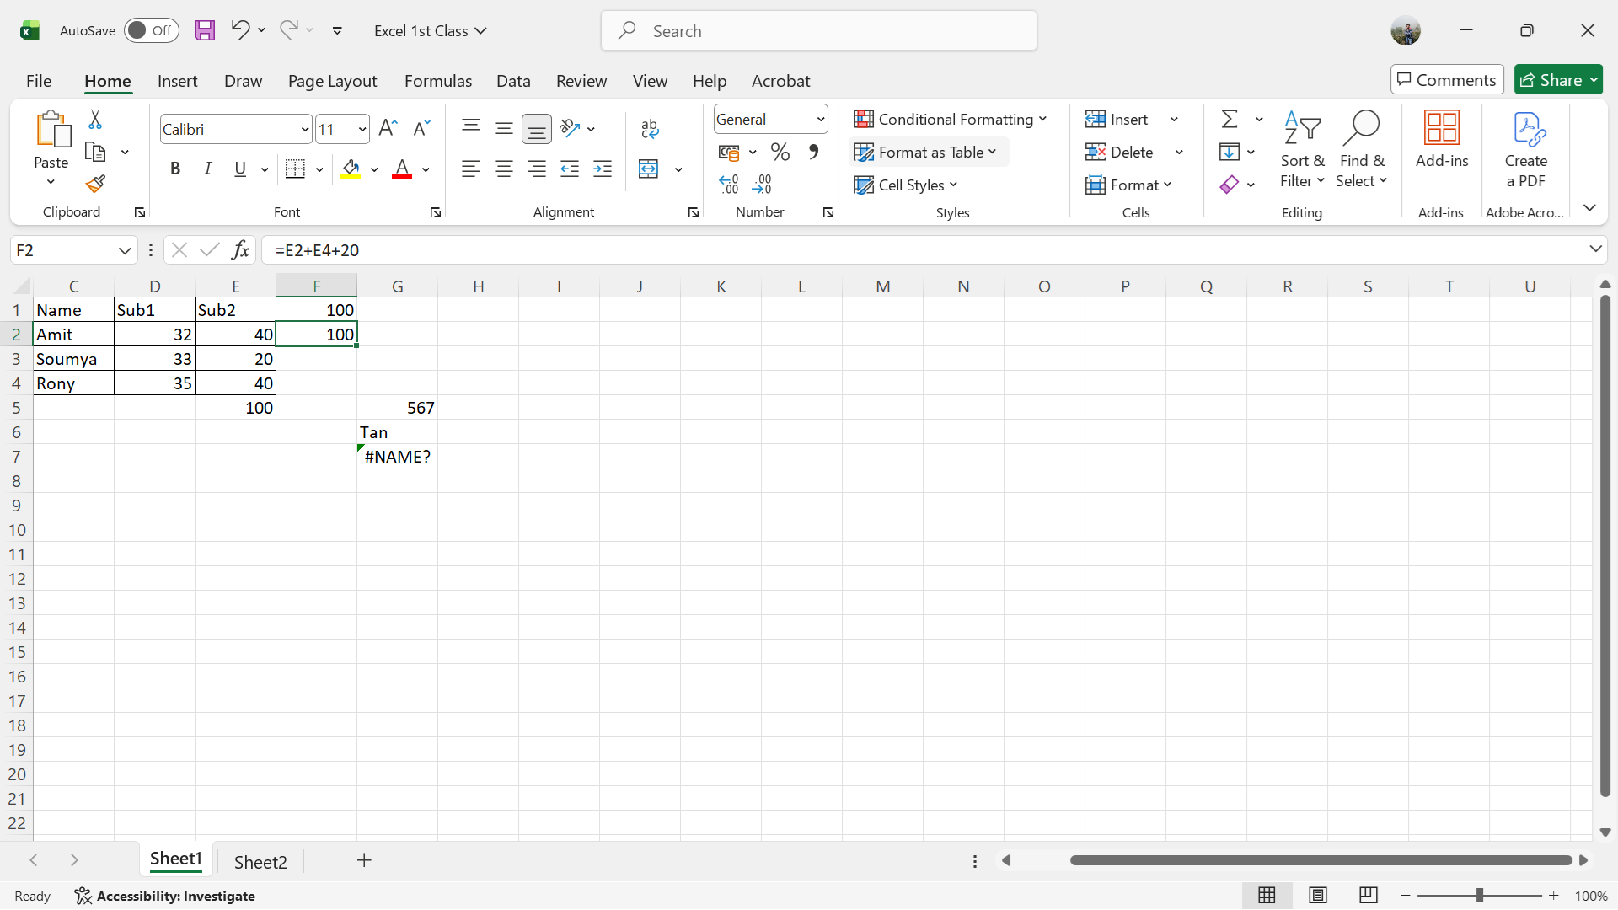

Avarage Using Formula:
- =ColumnRow/$Column$Row*100
